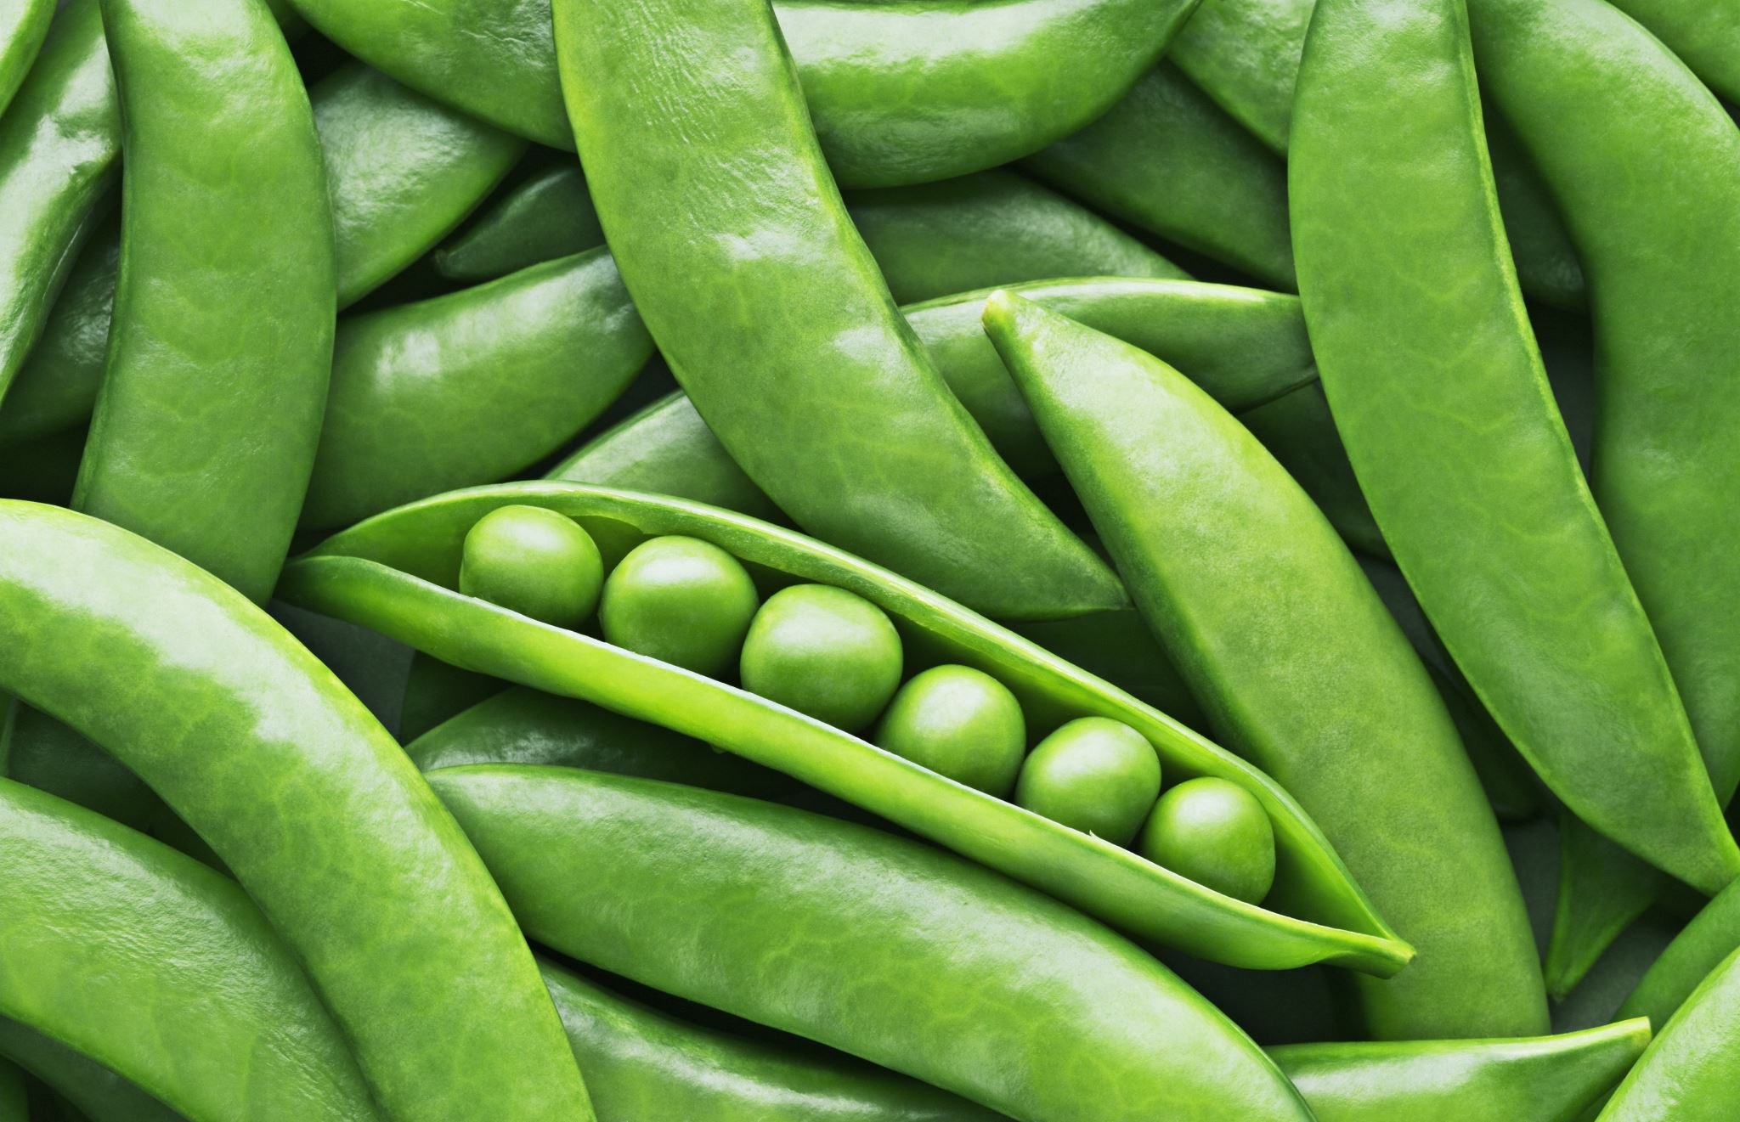

**How much does a school meal cost?**

A school meal is currently £2.75, this may be subject to change in September 2024.

**Free School Meals Eligibility**

We would like to remind you that some families are entitled to Free School Meals.

There are two important reasons why families should register for Free School Meals:

* students who are eligible receive a fresh nutritious hot Free School Meal every day.
* schools receive additional funding from the government for each eligible student who claims the Free School Meal allowance, even if the student doesn’t regularly eat a meal.

The process for parents to submit applications for Free School Meals is now entirely online, and so schools will be unable to provide hardcopy forms or submit your application form for you. This system gives families an instant indication as to whether their child is eligible for Free School Meals and ensures that eligible children receive their entitlement as quickly as possible.

Link to the online Free School Meal application form: [Free school meals - West Sussex County Council](https://www.westsussex.gov.uk/education-children-and-families/schools-and-colleges/free-school-meals/#how-to-apply)

The Catering Services Free School Meal team will then run further checks and confirm the outcome via email. You can contact the Catering Services Free School Meal team directly on 0330 222 5555 or at [fsm@westsussex.gov.uk](https://schools.westsussex.gov.uk/Newsletter/ExternalLink/172507?source=newsletter&guid=63FFB13B-5379-47A4-AFA4-07AFE8603BD7) for further assistance.

**Other key contacts:**

* Orders / Payments / Cancellations - Your school office.
* Special Diets - Your school office in the first instance.
* Catering Services Office Hours – 09.00 – 17:00, Mon-Fri.
* Compliments / Complaints/ Feedback

catering.advisory.service@westsussex.gov.uk

Special School Meal

Information

Welcome to your new School meals menu for 2024/25. School meals are free for all pupils in Reception, Year 1 and Year 2 and for pupils who are entitled to Free School Meals. For pupils in other years meals can be ordered and paid for via the school.

Catering Services work with the Lead Association for Catering in Education (LACA) to ensure that our menus comply with the Government’s School Food Standards. We have reduced sugar, salt and fat content on our menu and support local suppliers providing fresh meat and vegetables. Our meals are produced in school by our award-winning teams to support your child’s lunchtime experience. We have recently partnered with ProVeg helping to make changes to our menu that can have a big impact on children’s health and the health of the planet.

**How do I order and pay for a School meal?**

All meals must be ordered via your school payment system please contact your school administrator. If you are entitled to Free School Meals or your child is in Reception, Year 1 or 2 the school will order for you direct to Catering Services and you do not need to contact the school after your initial order.

**What happens if my child is sick and cannot attend School?**

Please contact the school office as soon as possible to inform them your child will be absent and will not require their meal.

**What happens if my child has a school trip?**

Free School Meals and pupils in Reception, Years 1 & 2 will be provided with packed meals on trip days, the school will order directly with Catering Services. Paid meals should be ordered with your school as usual.

**What if I require a special medical diet?**

We can work with you and the school to support a medically prescribed special diet. Please ask for a Special Diet Request form from the school office, once completed return with the medical evidence to the school office. This request will then be passed to and reviewed by the Catering Services team and where possible a special diet meal will be provided.

# **Special School Menu 2024/25**

|  |  |  |  |
| --- | --- | --- | --- |
| **Week 2** | | | |
| 22nd Apr, 13th May, 10th Jun, 1st Jul, 22nd Jul, 16th Sep, 7th Oct, 4th Nov, 25th Nov, 16th Dec, 20th Jan, 10th Feb, 10th Mar, 31st Mar | | | |
|  | **MAINS** | **SIDES** | **DESSERT** |
| **MON** | **Option 1:**  Cheese & Pepper Pizza Slices V  **Option 2:**  Sweet & Sour Quorn & Rice V | Peas, Sweetcorn VE  &  Carrots VE | Chef’s Oaty Fruit Crumble VE &  Custard V |
| **TUES** | **Option 1:**  Chicken Curry & Rice  **Option 2:**  Baked Beans & Cheese Jacket Potato V | Country Mixed Vegetables VE | Orange Frosted Carrot Cake V |
| **WEDS** | **Option 1:**  Roast Pork  **Option 2:**  Baked Lentil Roast V | Roast Potatoes VE  Carrots, Swede VE &  Cabbage VE | Fruit Strudel &  Cream V |
| **THURS** | **Option 1:**  Shepherd’s Pie  **Option 2:**  Quorn Casserole V | Mashed Potatoes V  Cauliflower VE  &  Green Beans VE | Fruit Flapjack VE |
| **FRI** | **Option 1:**  Tuna Pasta Bake  **Option 2:**  Crunchy Vegetable Goujons VE | Herby Diced Potatoes VE  Chef’s Choice Vegetables VE  &  Broccoli VE | Chocolate Brownie V |

|  |  |  |  |
| --- | --- | --- | --- |
| **Week 3** | | | |
| 29th Apr, 20th May,17th Jun, 8th Jul, 2nd Sep, 23rd Sep, 14th Oct, 11th Nov, 2nd Dec, 6th Jan, 27th Jan, 24th Feb, 17th Mar | | | |
|  | **MAINS** | **SIDES** | **DESSERT** |
| **MON** | **Option 1:**  Classic Macaroni Cheese V  **Option 2:**  Quorn Chilli & Rice V | Country Mixed Vegetables VE  &  Green Beans VE | Apple  & Berry Crumble Jack VE |
| **TUES** | **Option 1:**  Chicken  & Thyme Pie  **Option 2:**  Lentil  & Mushroom Pasta Bake VE | Carrots VE  &  Sweetcorn VE | Pear & Chocolate Sponge V  &  Chocolate Custard V |
| **WEDS** | **Option 1:**  Beef Bolognaise  **Option 2:**  Golden Cheese & Onion Turnover V | Garlic Bread V  Potato Wedges VE  Cauliflower VE  &  Peas VE | Fruit Smoothie VE |
| **THURS** | **Option 1:**  Roast Chicken  **Option 2:**  Quorn Roast VE | Roast Potatoes VE  Swede VE  &  Cabbage VE | Cinnamon Bun V |
| **FRI** | **Option 1:**  Fish Fingers  **Option 2:**  Beanie Wrap V | Chips VE  Broccoli VE  &  Baked Beans VE | Apricot Oat Cookies V |

|  |  |  |  |
| --- | --- | --- | --- |
| **Week 1** | | | |
| 15th Apr, 6th May, 3rd Jun, 24th Jun, 15th Jul, 9th Sep, 30th Sep, 21st Oct, 18th Nov, 9th Dec, 13th Jan, 3rd Feb, 3rd Mar, 24th Mar | | | |
|  | **MAINS** | **SIDES** | **DESSERT** |
| **MON** | **Option 1:**  Quorn Hotdog in a Soft Roll V  **Option 2:**  Cheese & Onion Frittata V | Diced Potatoes VE  Broccoli VE  &  Sweetcorn VE | Chocolate Whip  &  Strawberry Puree V |
| **TUES** | **Option 1:**  Roast Chicken  **Option 2:**  Chickpea Roast V | Roast Potatoes VE  Swede VE  &  Cabbage VE | Chefs Choice Fruit Muffin V |
| **WEDS** | **Option 1:**  Carbonara  **Option 2:**  Lentil Shepherdess Pie V | Garlic Bread V  Peas VE  &  Chefs Choice Vegetables VE | Sultana Cookie VE |
| **THURS** | **Option 1:**  Pork & Apple Sausage Roll  **Option 2:**  Soya Meatballs in Herby Tomato Sauce V | Herby Potato Wedges VE  Baked Beans VE &  Country Mixed Vegetables VE | Fruit Portion VE  &  Strawberry Milkshake V |
| **FRI** | **Option 1:**  Southern Spiced Burger V  **Option 2:**  Potato Topped Salmon Pie | Mashed Potatoes V  Cauliflower VE  &  Carrots VE | Chocolate  &  Apricot Cracknell VE |



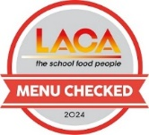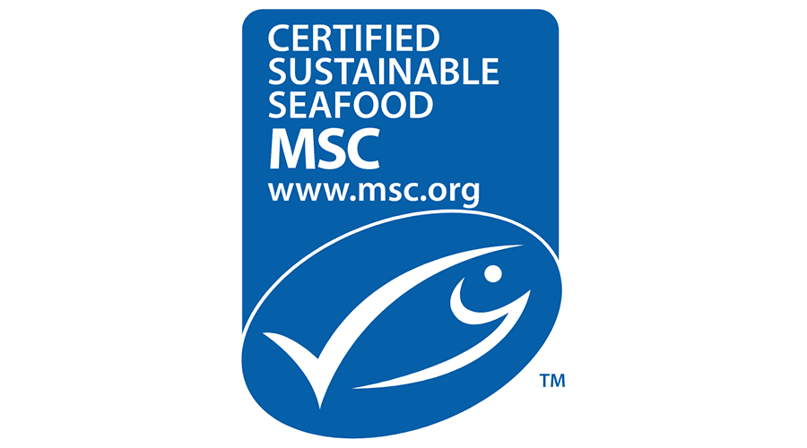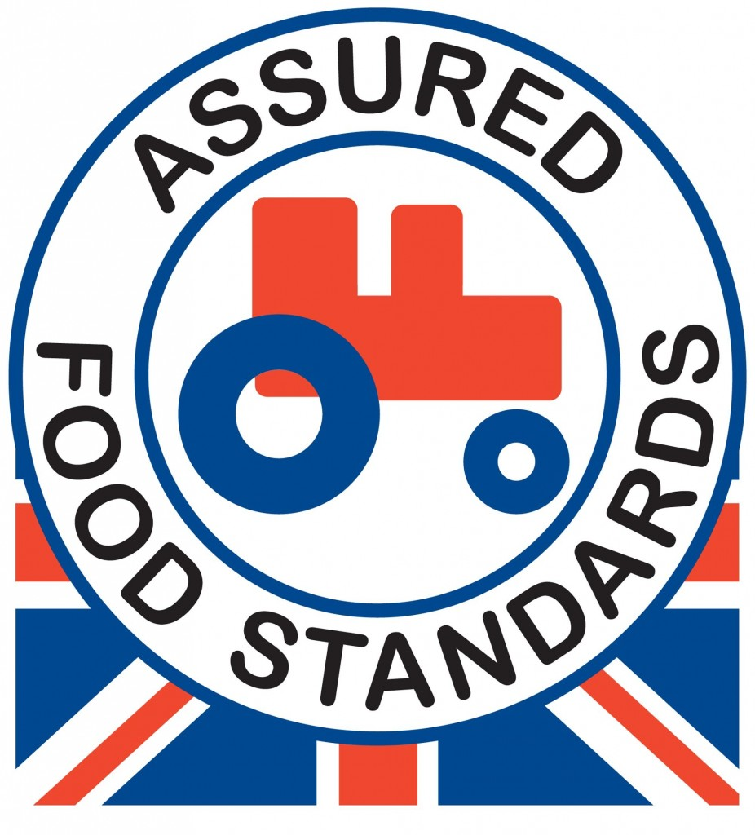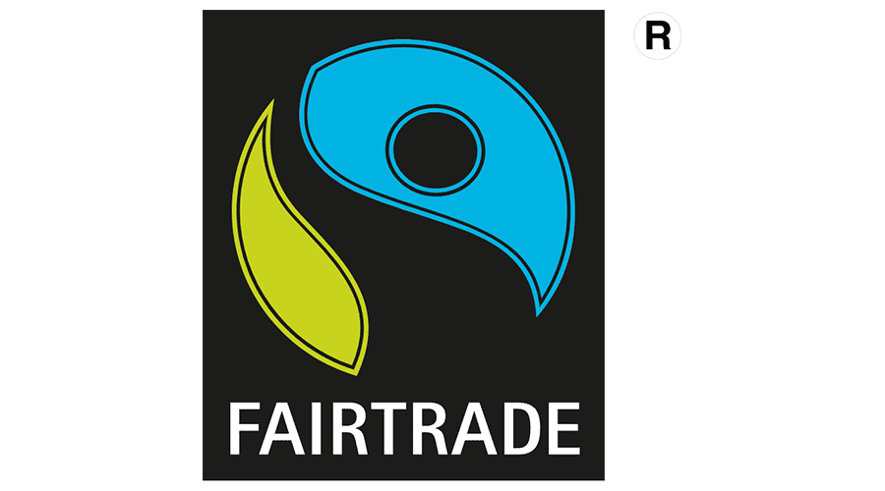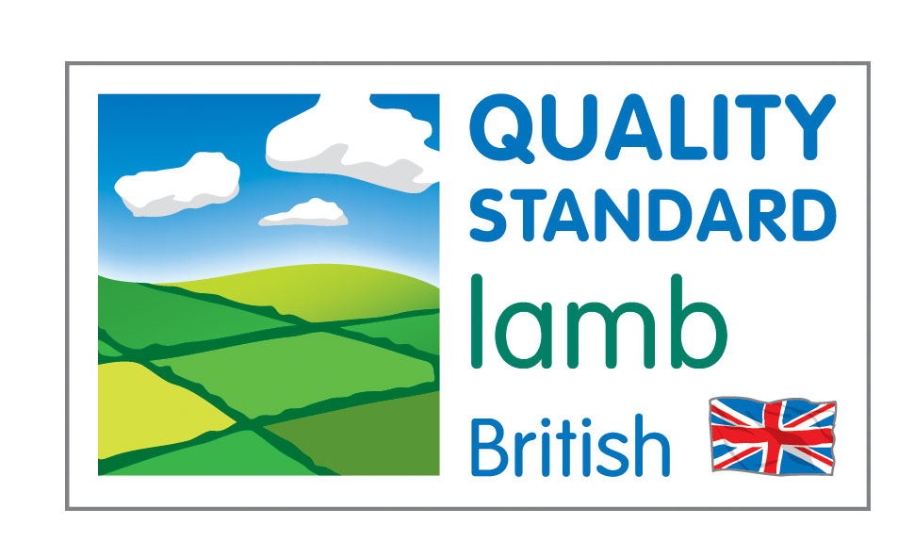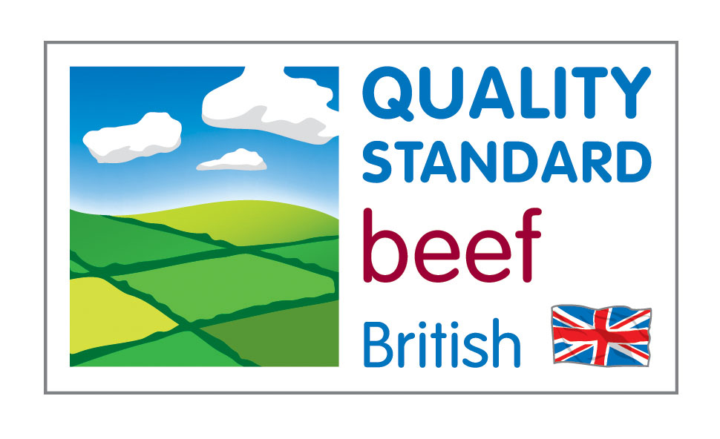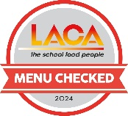

**Freshly baked bread V, water and milk V available daily.** **Additional dessert options - fresh fruit VE and fruit yoghurt V. V Vegetarian VE Vegan**

# **Special School Menu 2024/25**

Week 1

Week 2

Week 3