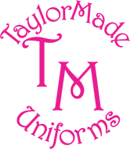



**01293 640154**

All school uniform is supplied by Taylor Made Uniforms; some of you may already know Zoe as she also supplies Manor Green Primary School and many other schools in Crawley and Horsham.



They offer a personal service and fittings can be arranged. They are also open evenings and weekends.



You can order uniform by telephone, email or through their website. Zoe will make deliveries to the school on Fridays or if you live locally to your house should you prefer.



Please visit their website [www.taylormadeuniforms.co.uk](http://www.taylormadeuniforms.co.uk) or call 01293 640154. Payment can be made by credit card, cash or cheque.

Location: Unit 1, Holmbush Potteries, Crawley Road, Faygate, RH12 4SE

(Opposite Kilnwood Vale, next door to Travis Perkins.)

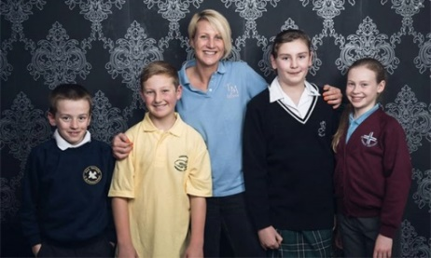

Manor Green College  
Lady Margaret Road  
Ifield  
Crawley  
West Sussex  
RH11 0DX  
Tel: 01293 520351  
Email: office@mgcollege.co.uk