**Literacy**

Speaking and Listening:

Working on personal communication targets, working with the SALT team as required.

Participate in discussion about what is read, taking turns and listening to what others say;

Ask relevant questions to extend their understanding Listen and respond appropriately to adults and peers;

Increasing vocabulary

Reading:

Reading Water related stories such as:

The Snail and the Whale

Tiddler

Pirates love underpants

to explore plot, characters and setting using Narrative therapy and colourful semantics

Storytelling and sequencing.

Retelling key events in topic texts.

Identifying main characters and the setting.

Answering questions in response to stories or events.

‘WHO? WHAT? WHERE?’

Phonics: Personalised to individuals

Writing:

Character descriptions, sequencing words and pictures and responding to core text.

Fiction focus: Water related stories

Information Texts: Using non-fiction texts to research water

**Maths/Numeracy**

About the Unit:

We will be following the Early Years Foundation Stage (EYFS) curriculum guidelines and elements take from KS1 Year 1.

Early Number

Using number songs, stories to count & sequence numbers. Counting in the environment and practice our counting. Counting objects to specific amounts, finding one more and one less and ordering numbers, place value and using number lines. Puzzles, number games and problem solving activities.

Number

Using and recognising numbers up to 30. Simple addition and subtraction, counting in 5s, 10s

Capacity and Volume

Full/empty, more than, less than, half, half full

**Computing and Online Safety**

Developing ICT Skills – logging on and navigating round familiar websites.

Cross Curricular – using Educationcity and sumdog for maths and literacy

SPRING Term

3EJ 2023

Water topic



**PSHE**

**We will be following the KS1 curriculum guidelines (updated July 2019): ‘***teaching the fundamental building blocks and characteristics of* ***positive relationships****, with particular reference to friendships, family relationships, and relationships with other children and with adults’.*

*This starts with pupils being taught, about what a relationship is, what friendship is, what family means and who the people are who can support them. From the beginning of primary school, building on early education, pupils should be taught how to take turns, how to treat each other with kindness, consideration and respect, the importance of honesty and truthfulness, permission seeking and giving, and the concept of personal privacy’.*

**TWAU**

**Water Topic**

Locational Knowledge & Human and physical Geography

Looking at beaches, coasts, seas and rivers

Hot and cold places

Observe changes in the weather

Creatures and animals found in the ocean

Different weather – rain, snow, hailstones

Rainforests

Looking at how water is used around the house and at school

Experiencing water in the local environment

**RE/Citizenship**

Citizenship – Children’s Rights and responsibilities

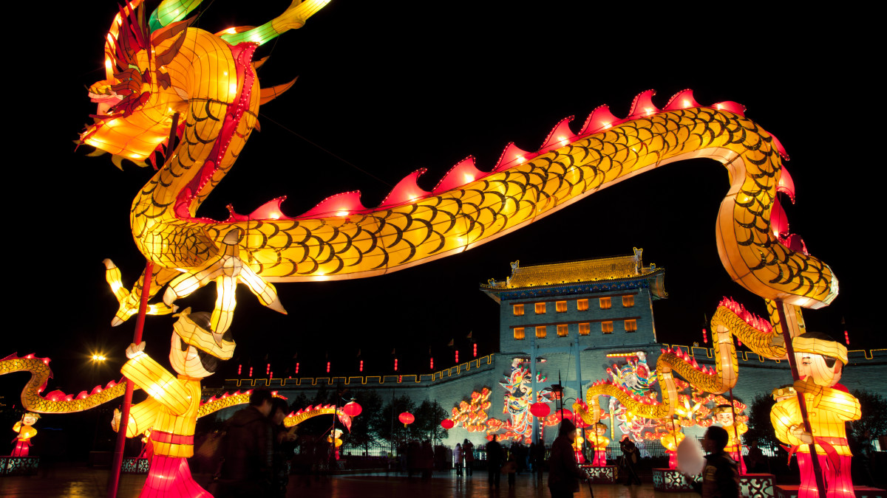

RE – Chinese New Year

**Science**

**Plants**

Looking at what plants need to grow

Naming the parts of the plant

Growing their own plants from seeds

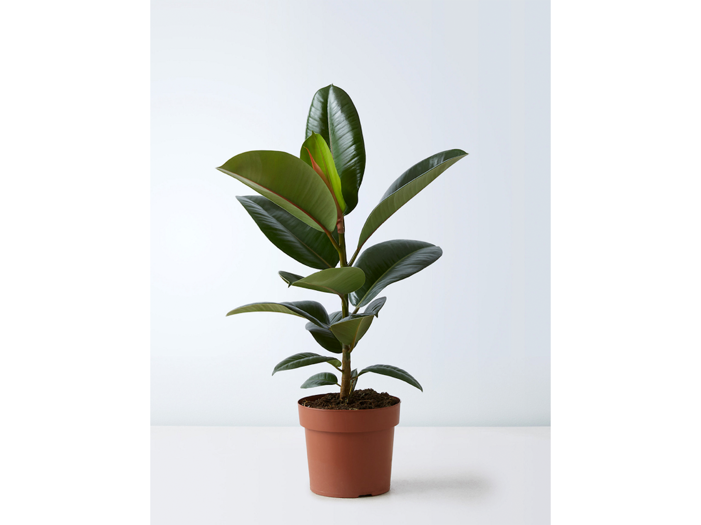

**Drama**

Cross curricular links incorporating the water topic.

Sensory drama games and activities including:

Sailing on a cruise ship

Going on a pirate adventure

MYTHS &

**Life Skills/ Community Visit/QUEST/Forest**

To visit parks, garden centres, gardens (National Trust) and places linked to our water topic

**Forest schools**

Students will be taking part in Forest School offering students regular opportunities to achieve, and develop confidence and self-esteem through hands on learning experiences in a local woodland environment.

Activities will include elements of natural crafts, games are played and small achievable tasks will be offered such as hide and seek, building shelters, learning how to use appropriate tools, lighting fires, wood/bush crafts, outdoor cooking, climbing and exploring the woodland.

The participants learn basic woodland skills as a method to try and boost their self-confidence and raise their self-esteem. The participants learn to use natural materials and develop practical skills.

**Art/DT**

Art – Exploring Portraiture. Throughout history and across cultures, artists and makers have shown a fascination with human faces, whether to reveal something of themselves or to express characteristics, ideas or personalities. Students will look at proportion and use colour, pattern and words to create self-portraits.

DT - sculpting shells using clay, designing and making paper Mache stones and pebbles to contribute to a class rock pool diorama/small world play.

3EJ SPRING Term

2023

Water topic

**PE**

This term Matt from Sussex Cricket is teaching the class Table Cricket. The objectives are:-

* Develop skills involved in participating in the activity
* Understand the rules and conventions of the activity
* Develop social skills in teamwork aspect of activity
* Work towards a Table Cricket Tournament at Hove Cricket Ground next term against other schools