**Computing and Online Safety**

**Digital Images**

This term, students will be developing their understanding of how digital images can be changed and edited. They will be using a specific piece of software to edit and change images and learn how to resave these as new images. They will consider the impact that editing images can have, and evaluate the effectiveness of their editing choices.

**e-Safety**

Safer Internet Day is on **7th February 2023** and so students will be focusing on e-Safety alongside their core learning on digital images this term. They will identify risks associated with the different apps/programmes that they use and identify ways to manage these risks in order to protect their safety and the safety of their data/information.

**English/Reading/Drama**

**Writing**

Our class text this term is **The Boy At The Back Of The Class** by Onjali Q. Rauf**.**

The story focuses on Ahmet, a Refugee from Syria and how his new friends at his new school want to help him…so they come up with a plan!

Students will respond to illustrations, making initial perceptions, picking out characteristics of a person and then making logical predictions.

We will also focus on how language affects our interpretation of a situation and how imagery used can be persuasive. Students will also be encouraged to understand the perceptions of others by looking at the language used.

**Guided Reading**

Reading **The Boy At The Back Of The Class** to explore plot, character and setting. Checking comprehension and ability to follow the story line.

Practising reading aloud as part of a small group to focus on expression, pace and intonation.

**Drama**

We are continuing to work on our Alice in Wonderland theme following ideas from The Royal Opera House.

This will encourage students to:

* Promote a “yes” way of thinking so that students can be as creative as they feel comfortable to be.
* Build their confidence and self-esteem.
* Engage with the story and create empathy.

**Science**

This term, students will be learning about **electricity**. Students will be constructing a variety of simple series circuits using cells, wires, bulbs, buzzers and switches. They will then learn about how to represent these as diagrams using scientific symbols. Students will learn about the difference between complete and incomplete circuits and be able to troubleshoot a variety of incorrect circuits. Students will also learn about common electrical appliances and what makes a material a good conductors or insulator of electricity. At the end of our unit, students will create a wire buzzer game to showcase their learning.

**Maths**

This term, the primary focus in maths is **multiplication and division**.

We will be beginning with recapping/learning times table facts up to 12x12 and learning about the related division facts, e.g. 6 x 3 = 18, 3 x 6 = 18, 18 ÷ 3 = 6 and 18 ÷ 6 = 3. We will also be multiplying three 1-digit numbers together. Students will be working on calculations, missing number questions and more complex word problems relating to these times tables.

Following this we will be recapping/learning these formal written methods for multiplication and division:

Column Multiplication 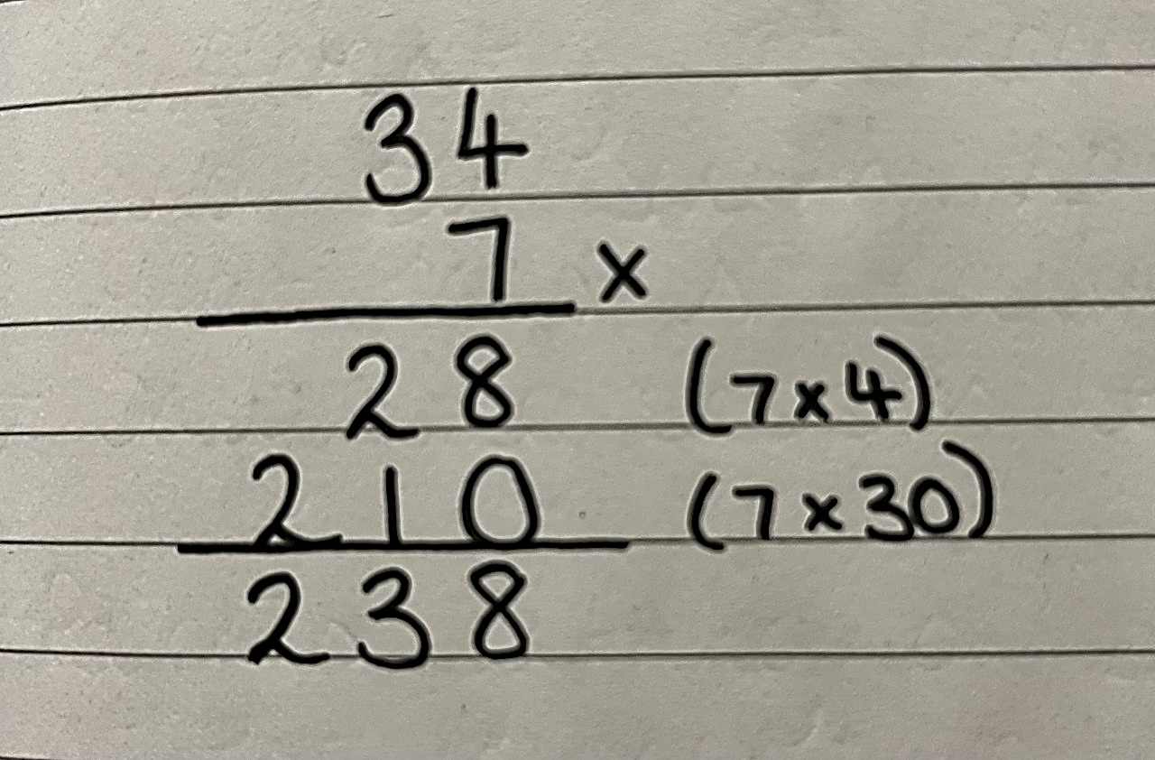 ‘Bus Stop’ Division 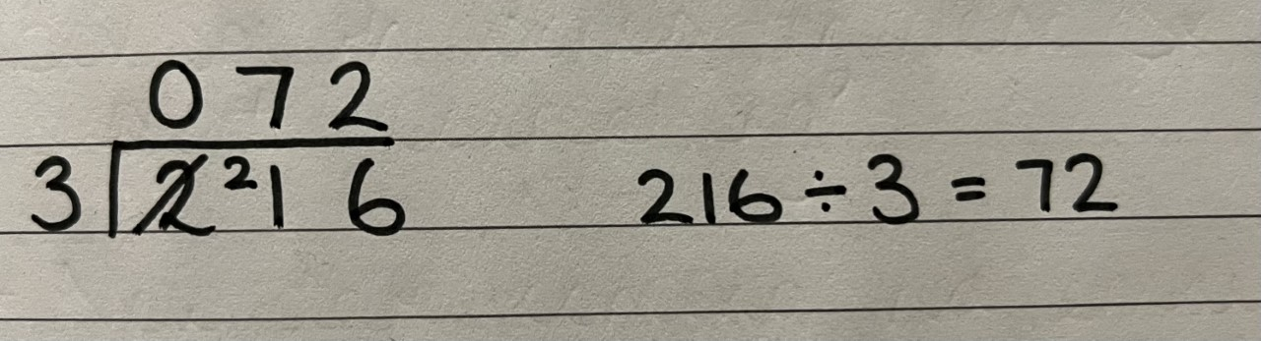

SPRING Term

2023

**Duke of Edinburgh’s Award**

**(Year 9 Students Only)**

During their DofE sessions, students will be supported to work towards their Bronze Award.

This term, the focus continues to be their **skills and volunteering sections**.

**Citizenship**

This term, students will be looking at the **work and role of charities**. They will be explaining why a charity’s work is worthwhile. Students will explore and give reasons why Manor Green College supports charities such as Children in Need, Red Nose Day, Jeans for Genes etc.

**Cooking**

Students will prepare and cook a variety of recipes throughout the term. This term’s focus is on being able to **safely and efficiently cut, chop and slice ingredients**.

Students will practice following a recipe broken down into steps and use skills such as rolling out, accurate weighing and measuring and the use of an oven and hobs to cook meals.

**Life Skills/Community Visit/QUEST**

**(Year 8 Students Only)**

During their life skills sessions, students will learn about taking responsibility for themselves whilst out in the local environment and community.

This term, the primary focus is **swimming**. Students will increase their confidence in water and independence when changing. They will also learn about etiquette when out in public and water safety/what to do if they become distressed when in the water.

**The World Around Us**

We will look at the development of the **Railways in Great Britain** giving them the opportunity to find out about the history of the railways and significant early locomotives.

They will also investigate some important historical events, such as the opening of the first passenger carrying railway lines and they will learn about some of the key people who were influential in the development of the railways. In addition to this they will learn about the development of locomotive technology and examine the differences between steam, diesel and electric locomotives.

**PSHE**

This term is all about **self-awareness**. During this unit, students will explore their own personal strengths and skills. They will discuss recognising and highlighting the strengths/skills of other people and how to celebrate these. We will spend some time looking at images used in adverts, discussing whether they are a true or enhanced representation of their subject. Students will also discuss the impact of adverts on themselves and others. Students will learn about different learning styles and how to recognise what works well for themselves. We will also be looking at prejudice and discrimination.

**PE**

**The two main activities this term will be table tennis and Boccia. The focus will be on**

* **Social interaction with peers**
* **Developing new physical skills and applying in context**
* **Developing communication**
* **Developing confidence to experience different activities**
* **Understanding the nature of success in different types of activity and values of sportsmanship**

**Art/DT**

**Art**

Exploring Portraiture. Throughout history and across cultures, artists and makers have shown a fascination with human faces, whether to reveal something of themselves or to express characteristics, ideas or personalities. Students will focus on **Frida Kahlo, Van Gogh, Delita Martin** and create their own mixed-media portraits.

**DT**

This term, students will create **scrap wood sculptures** inspired by Charles Goldman.

SPRING Term

2023