**Maths/Numeracy**

Number– focusing on numbers up to 20. Ordering and simple calculations including addition and subtraction. Number is taught using lots of visual / kinaesthetic games and concrete resources. Some students will be learning to use a number line.

Money – Practical use of money in the community. Handling money and completing transactions.

Recognising British coins and notes.

Attention Autism to link in with maths

Stage 1 – Gain attention with bucket

Stage 2 – Build attention and go slow and fast

Stage 3 – Children switch attention and join in activity

Stage 4 – Transition into main maths task with named pots

Links to White Rose maths reception and year 1: <https://whiterosemaths.com/resources>

Personal targets

**Literacy**

**Key texts linked to topic transport:**

**The Train Ride – Julie Crebbin** [**https://www.youtube.com/watch?v=jHbE8kaBDKU&t=2s**](https://www.youtube.com/watch?v=jHbE8kaBDKU&t=2s)

**Starlight Express – Linked to KS4 production –**

**Seasons and festivals – The Dragon in the City linked to Chinese New Year** [**https://www.twinkl.co.uk/resource/us-l-622-dragons-in-the-city-story-powerpoint**](https://www.twinkl.co.uk/resource/us-l-622-dragons-in-the-city-story-powerpoint)

**We are all different:**

[**https://www.twinkl.co.uk/resource/tf-or-35-we-are-all-different-story-powerpoint**](https://www.twinkl.co.uk/resource/tf-or-35-we-are-all-different-story-powerpoint)

**Looking at similarities and differences**

Makaton for key vocab and communication skills

Singing hands and Mr Tumble on YouTube for Makaton

Colourful semantics programme to develop sentence structure

Topic focus role play links

Storytelling and sequencing- retelling key events in topic texts

Answering questions in response to stories or events

Understanding and responding to instructions and events

Students learn to express themselves effectively, showing awareness of the listener’s needs

Phonics

Pre-reading and reading skills

Name writing and correct letter formation

Personal targets



SPRING Term

2023

**Computing and Online Safety**

Developing basic ICT skills including using a keyboard and mouse, typing, clicking, searching according to ability.

Cross curricular - using Education City

Using cameras & iPads

Turtlediary.com – preschool



**Science**

We are continuing to work towards achieving STAR Crest Awards. Our hands-on weekly challenges help us to understand the world around us. Upcoming investigations include Peggy Problem (grip and strength), Muddy Mess (washing materials) , Slippery Slopes (friction) and Winter Warming (insulation)

**PSHE**

We are all different: <https://www.twinkl.co.uk/resource/tf-or-35-we-are-all-different-story-powerpoint>

Looking at similarities and differences

Things we like / choices

Personal targets

**Life Skills/ Community Visit/QUEST**

Supported visits in the community

Our focus during our QUEST visits will be on

* Shopping skills and handling money
* Travel training in the community
* Social etiquette in the community
* Experiences places of nature
* Forest School

This term we also have a trip to Worthing Art Gallery for Art Awards with the Art therapist , Sally.

**RE/Citizenship**

Chinese New Year

Black History Month

Valentines

Ramadan

Easter

Children will learn about the important events above and celebrations in real time.

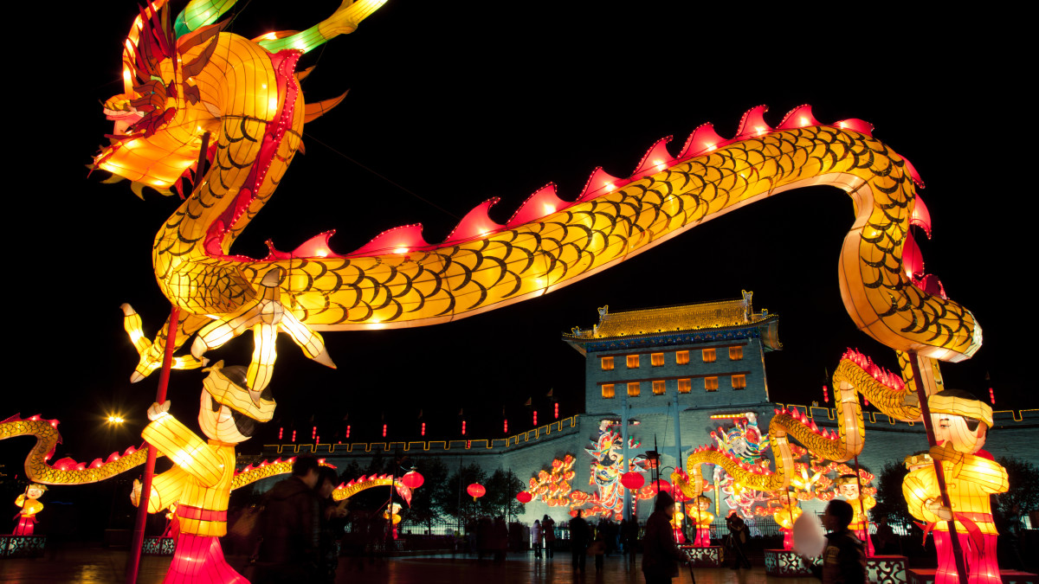

**Cooking**

Developing essential life skills including washing, chopping, grating, frying, baking, boiling of food

Washing up/drying up

Basic food preparation and food hygiene

Cooking based on last terms ICT choices including pizza puff wheels, chocolate chip cookies, muffins, egg fried rice, jacket potato, spaghetti bolognaise– 4IP

Savoury foods – 4JP

**PE**

**Classroom exercises based on individual physio programmes focusing on mobility and strength.**

Class PE lessons will be focusing on team games this term, starting with football. Skills that we will be looking at include

* Passing & receiving a ball (e.g. kicking, throwing)
* Moving with a ball (e.g. dribbling)
* Stopping a ball (e.g. controlling a football, catching & hand eye coordination skills)
* Communicating as part of a team.

SPRING Term

2023

**Art/DT**

Art - 'Pet Monsters'  In this unit students will develop their understanding of shape, form, colour, texture and design iteration. They will investigate the qualities of a variety of textile materials and learn skills for stitching, applique and embellishment. All students will make a soft sculpture Pet Monster. Evaluation is a key part of this scheme of work.