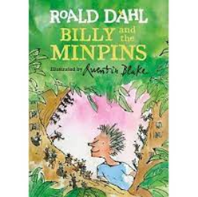

**Literacy**

**Guided reading lessons:**

Students to take part in

guided reading lessons once a week,

using phonic books reading schemes.

**Intervention lessons:**

Students will complete weekly spelling, handwriting, and comprehension interventions.

**Drama lessons:**

**Student**s to take part in weekly Drama lessons where they will complete activities to develop use of their voice, body and expression in contrasting performances / activities.

**Text based lessons:**

Students will take part in weekly text based English lessons covering a range of different writing and reading genres, completing numerous activities inc; descriptive writing, writing in a diary style, instructional writing, retrieval of information from a nonfiction text, poetry, character profiles/descriptions, writing for an advert, comic strip/captions and speech bubbles, letter writing, comparing fact / fiction.

This terms text is Billy and the Minpins by Roald Dahl.

**Maths/Numeracy**

Students continue to work through the White Rose Maths scheme of work, covering key strands within the maths curriculum:

-Addition and subtraction At home students can practice

-Shape their Maths on Sumdog.

-Money

-Multiplication and division

-Length and height, perimeter

-Fractions

-Mass, capacity, and temperature

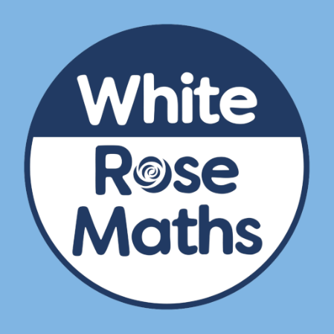



**Computing and Online Safety**

This term we are focusing on skills of using Publisher and internet safety

Tuesday 7 Feb’23 Internet safety day.

SPRING Term

2023

3 GB & 3 JB

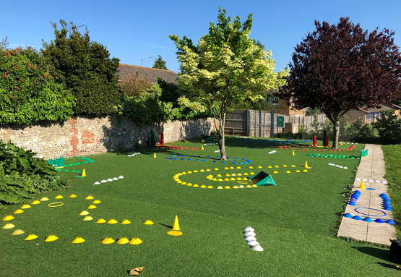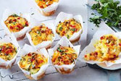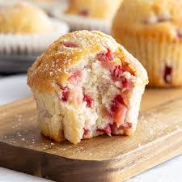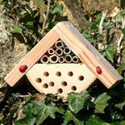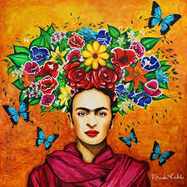

**Life Skills/ Community PE**

**Visit/QUEST**

-The Local Environment JOLF with

-To follow trails/read maps Neil Plimmer

-The Local Community

-This may include:

Library:

Supermarkets

Law courts

Fire service

-Compare amounts of money

using place value knowledge. And Table Tennis

**The World Around US**

-History of music.

-Our world; Continents & Oceans.

**RE / Citizenship**

-Justice & Freedom

-Crime and Punishment

**PSHE**

-Drugs education focusing on smoking, alcohol and peer pressure.

-Sex and relationships including personal hygiene, puberty, attraction, and reproduction.

**Science**

-Changing materials and the digestive system.

**Cooking**

Students will focus on hygiene, cleaning, washing up, creaming, mixing, whisking, chopping, grating, peeling, mashing, and developing skills around measuring liquids and solid items. Sweet and savoury muffins and cupcakes, granola and flapjack, ideas for breakfast, (Breakfast week 7-11 March’23), sweet and savoury pasty skills with fillings.

**Art DT**

Exploring Portraiture. Throughout history

and across cultures, artists and makers have shown a fascination with human faces, whether to reveal something of themselves or to express characteristics, ideas or personalities. Students will look in particular at Frida Kahlo, Van Gogh, Delita Martin and create their own mixed-media portraits.

Bug boxes concentrating on

batch production techniques

and wood joints.