**Literacy**

**Core text: I was there 1066.**

This story follows a young Anglo Saxon boy of noble parents who follows his father into battle.

We will be using this text to explore our history topic, which is the Norman Invasion.

Through the text we will be:

* Interpreting images.
* Retrieving facts
* Discussing events
* Exploring a range of perspectives.
* Using past tense vocabulary
* Diary writing.

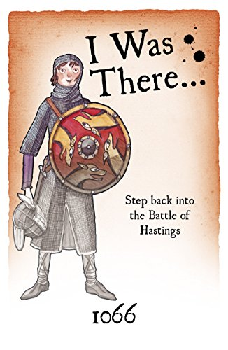

**Maths/Numeracy**

This term, students will be focusing on fractions based activities such as:

* Understanding that a fraction can describe part of a set.
* Find fractions of shape.
* To recognise fractions
* To understand what a denominator and what a numerator is.
* To find equivalent fractions without crossing whole numbers
* To find equivalent fractions crossing whole numbers.
* To find fractions of number

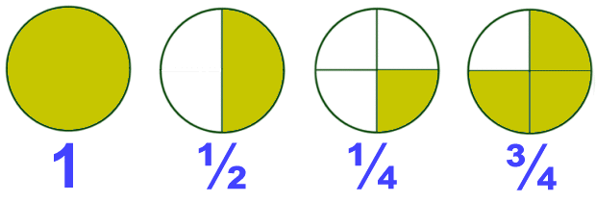



**Science**

Students will be learning about the human body and animals focusing in on:

- The Circulatory System

- Respiratory system

- The skeletal system

- Nutrition and healthy eating.

**PSHE**

This terms PSHE will link to science, exploring the idea of healthy eating and exercise and what foods can do to our bodies. Links to this unit will also be made through our science lessons, cooking and community visits.

SPRING Term

2023

**Computing and Online Safety**

**Programming**

Students will be using scratch and Microbits to practice their coding skills to:

- Make simple games.

- Create simple animations.

- Programming LED lights.

- Send information via RF frequencies.

**RE/Citizenship**

Students will be exploring the idea of democracy in citizenship as well as a range of British values. In RE students will be recapping the Easter story and the morals that accompany it.

**TWAU**

**Norman Invasion of Britain.**

Students will be using information learnt during our Vikings and Anglo Saxons topic and linking it to the Norman invasion. Students will be:

* Sequencing the events leading up to the battle of Hastings.
* Sequencing the events during the battle of Hastings.
* Understanding the roles of key figures
* Understanding the perspective of the potential kings of England

**PE**

The focus activity this term will be table tennis. The objectives are

* Practicing fine & gross motor skills to support with control
* Developing understanding of how the game is played
* Develop social communication skills through modified games
* Applying numeracy skills to real life context

**Cooking**

This term, students will be using various techniques to produce bread and pasty foods. Skills such as:

-Rubbing in

-Rolling out

-Chopping

-Grating and Kneading

We are looking forward to tasting what we make!

**Life Skills/ Community Visit/QUEST**

Students will be participating in a range of activities at various supermarkets, shops, curriculum visits and national trust locations.

The focus this half term will be on social etiquette, monetary transactions and linking learning through PSHE, Science and cooking to the community and world around us.

**Art/DT**

This unit has been designed for students to continue their fine-motor skills and follows on from ‘Line, Shape and Colour’ to the controlled repetition of lines and shapes to create **Pattern**. This will help with pattern recognition and positive and negative space. Work will lead from pure monochrome to explore light and dark and will progress to colour. Learners will use artists such as Hunterwasser and Paul Klee as inspiration.  **Essential questions:** What is pattern? How do we use the world around us to see pattern and copy pattern?

SPRING Term

2023